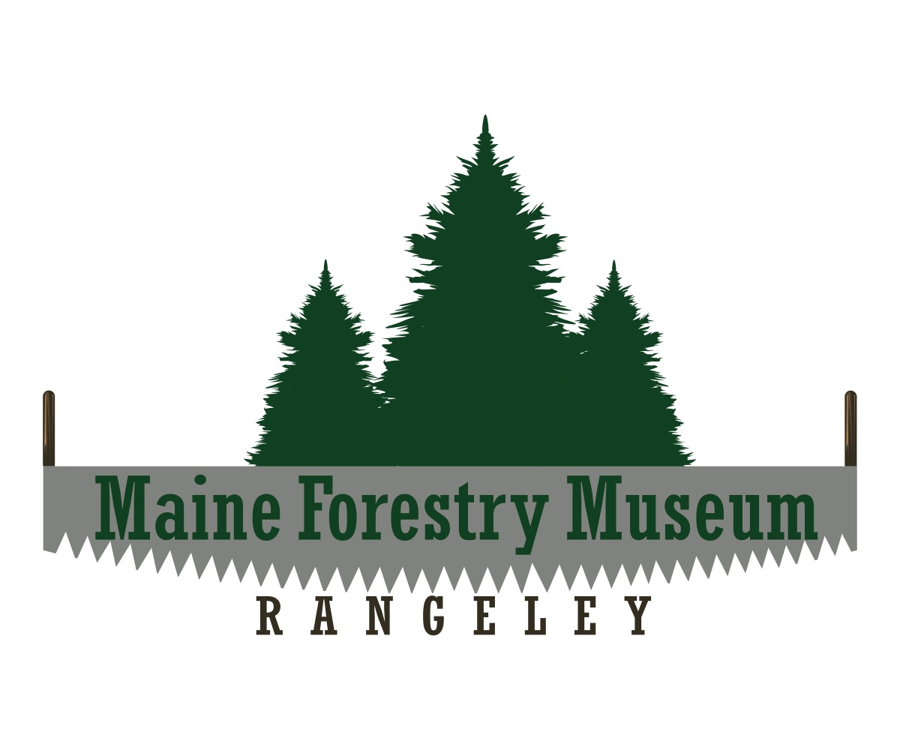

Competitor Registration Form

Maine Forestry Museum’s Logging Festival Days - Logging Competition
Saturday July 29th, 2017 at 12:00 PM

Registration Fee: $10.00

Prize Money: $25, $15, $10, $5 per event. The champion in each division wins a STIHL chainsaw.

Competitor Check­In and Registration Time: 10:00 – 11:30 am

General Information:

The competition will feature both a Lumber Jack and Lumber Jill competition.

PLEASE FILL OUT THE FORM BELOW AND CHECK OFF WHICH EVENTS YOU WISH TO COMPETE IN:

NAME:_________________________________________________________
ADDRESS:_____________________________________________________
PHONE: _______________________________________________________
EMAIL: _________________________________________________________

LUMBERJACK COMPETITION LUMBERJILL COMPETITION

___ Axe Throw
___ Log Roll ___________________________ (partner) (doubles event)
___ Crosscut __________________________ (partner) (doubles event)
___ Pulp Throw for distance
___ Stock Saw
___ Wood Split

Please mail your completed form and check made payable to Maine Forestry Museum to:

Maine Forestry Museum
ATTN: Logging Competition
P. O. Box 154
Rangeley, ME 04970

